Project Instruction

This is the instruction document to run our application.

Git repository -> <https://github.com/elhamvei/t21_rentitues.git>

1. Open terminal. (If windows use git bash)
2. Download the repository with this command:

git clone <https://github.com/elhamvei/t21_rentitues.git>

1. Go the project repository:

cd t21_rentitus

1. Open the project in visual studio code:

code .

1. In VS code terminal, instal node module, and run the server (both on backend and frontend by running these code separately by order):

cd frontend

npm install

npm start

cd ..

cd backend

npm install

npm start

1. Open xampp control panel (if it’s not installed, please intall):

Start “Apache”, “MySQL”.

1. Run this link in browser (project database view):

<http://localhost/phpmyadmin/index.php>

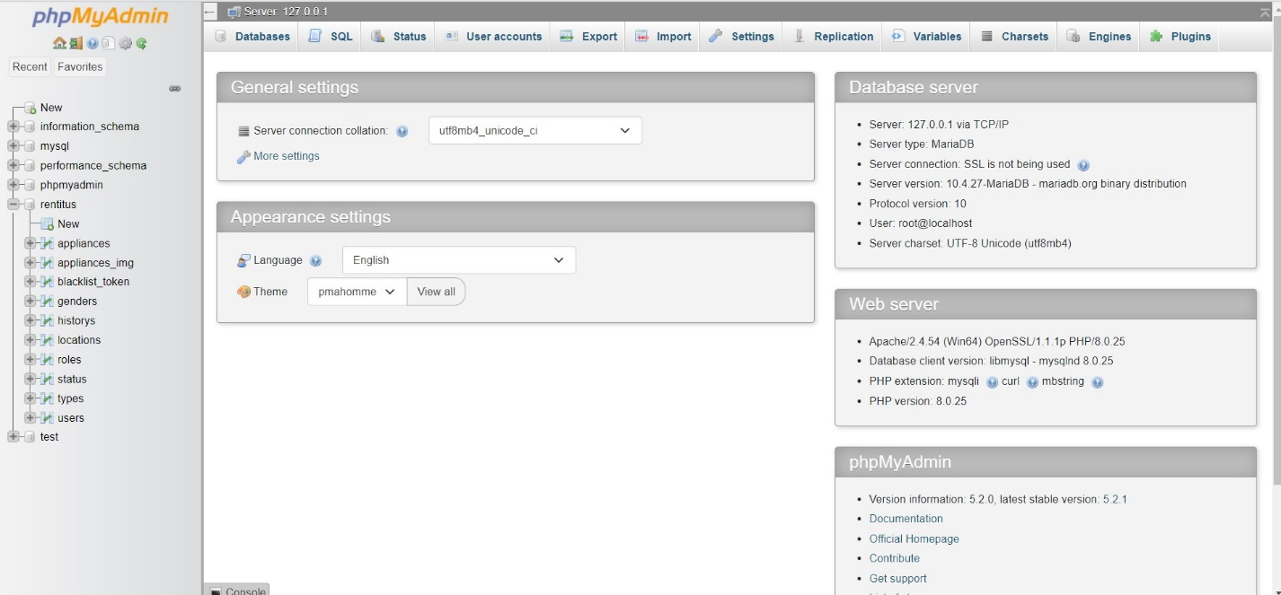

1. If you didn’t see “rentitus” database, click “new”, and add “rentitus” sql file uload it from the project folder.
2. Click “rentitus” and find “users”. There have several accounts we made during testing phase. You can chose one of the option, or you can sign up a new account on the application site, then activate new account in database from “users” menu, then back to our application website log in with your new account.

User 1 -> [veisouei@gmail.com](mailto:veisouei@gmail.com) password -> 123456

User 2 -> [lale@gmail.com](mailto:lale@gmail.com) passwrod -> 123456

1. If you would like to check the ‘Live Chat ‘ feature, there is the user account, and link for the Admin.

Link -> <https://dashboard.tawk.to/login#/wizard/4>

User -> [elham85@gmail.com](mailto:elham85@gmail.com)

Password -> 1qaz!QAZ

Now you are all set to view and play with our application! If you have any concerns please Email to our team’s Scrum Master ([Lale.Mulati@georgebrown.ca](mailto:Lale.Mulati@georgebrown.ca)), we’ll get back to you right away.

Other fellow team members email:

[Artem.Elagin@georgebrown.ca](mailto:Artem.Elagin@georgebrown.ca)

[Abdelaziz.Omar@georgebrown.ca](mailto:Abdelaziz.Omar@georgebrown.ca)

[Elham.Veisouei@georgebrown.ca](mailto:Elham.Veisouei@georgebrown.ca)